|  |
| --- |
| **Introduction to Java** |

Introduction to:

|  |
| --- |
| 1. Basic of Java 2. Comments, Variables Data Types, Arithmetic Operations 3. Exercises |

|  |
| --- |
| **Exercises** |

Exercise 1 (Mosque.java)

Write a program that prints a mosque, similar to the following:

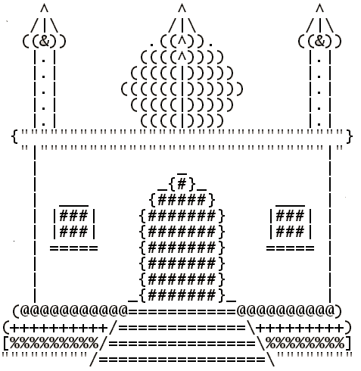  
**Source Code:**

package javalab1;

public class JavaLab1 {

public static void main(String[] args)

{

System.out.println(" ^ ^ ^");

System.out.println(" /|\\ /|\\ /|\\");

System.out.println(" ((&))) .((^)). ((&))");

System.out.println(" | . | ((((^)))) | . |"); System.out.println(" | . | (((((|))))) | . |");

System.out.println(" | . | ((((((|)))))) | . |");

System.out.println(" | . | (((((|))))) | . |");

System.out.println(" | . | ((((|)))) | . |");

System.out.println("\"\"\"\"\"\"\"\"\"\"\"\"\"\"\"\"\"\"\"\"\"\"\"\"\"\"\"\"\"\"\"\"\"}" );

System.out.println(" \"\"\"\"\"\"\"\"\"\"\"\"\"\"\"\"\"\"\"\"\"\"\"\"\"\"\"\"\"\"\"\"");

System.out.println(" | _{#}_ |");

System.out.println(" | {#####} |");

System.out.println(" | ___ {#######} ___ |"); System.out.println(" | |###| {#######} |###| |");

System.out.println(" | |###| {#######} |###| |"); System.out.println(" | ===== {#######} ===== |");

System.out.println(" | {#######} |"); System.out.println(" | _{#######}_ |");

System.out.println(" (@@@@@@@@@@=============@@@@@@@@@@)");

System.out.println("(+++++++++/===============\\+++++++++)");

System.out.println("[%%%%%%%%/=================\\%%%%%%%%]");

System.out.println("\"\"\"\"\"\"\"\"/===================\\\"\"\"\"\"\"\"\"\"");

}

}

**Output:**

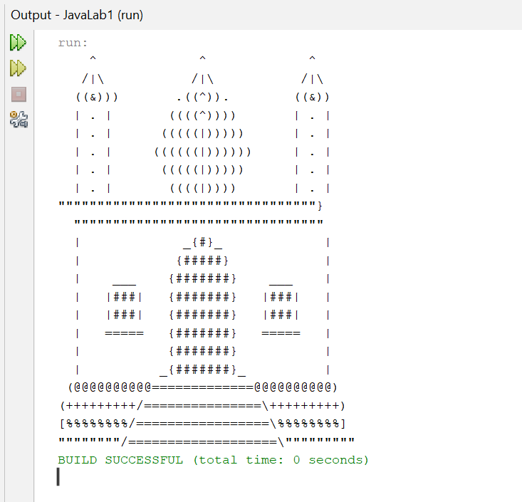

Exercise 2 (Equations.java)

Write a java program that calculates the following equation. Where x = 6, y = 20, z = 13;

2x² + y2

3x + y -3z²

2x -2y + 5z²

**Source Coode:**

package first_exercise;

public class First_Exercise {

public static void main(String[] args) {

// Given values

int x = 6;

int y = 20;

int z = 13;

// First equation: 2x² + y²

double equation1 = 2 * Math.pow(x, 2) + Math.pow(y, 2);

System.out.println("Result of the first equation (2x² + y²): " + equation1);

// Second equation: 3x + y - 3z²

double equation2 = 3 * x + y - 3 * Math.pow(z, 2);

System.out.println("Result of the second equation (3x + y - 3z²): " + equation2);

// Third equation: 2x - 2y + 5z²

double equation3 = 2 * x - 2 * y + 5 * Math.pow(z, 2);

System.out.println("Result of the third equation (2x - 2y + 5z²): " + equation3);

}

}

**Output:**

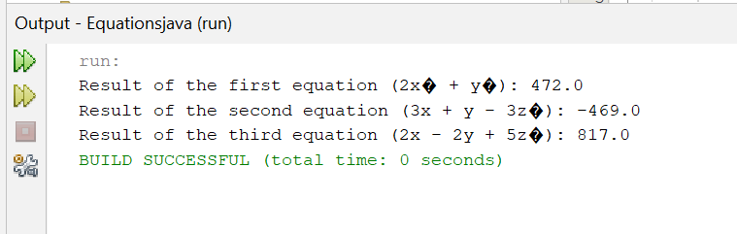

Exercise 3 (Arithmatic.java)

Create a Java program which receives the input of two integer numbers and compute the sum, difference and product. Compile and run this program.

**Source Code:**

package first_exercise;

import java.util.Scanner;

public class First_Exercise {

public static void main(String[] args) {

Scanner scanner = new Scanner(System.in);

System.out.print("Enter the first integer: ");

int num1 = scanner.nextInt();

System.out.print("Enter the second integer: ");

int num2 = scanner.nextInt();

int sum = num1 + num2;

int difference = num1 - num2;

int product = num1 * num2;

System.out.println("Sum: " + sum);

System.out.println("Difference: " + difference);

System.out.println("Product: " + product);

scanner.close();

}

}

**Output:**

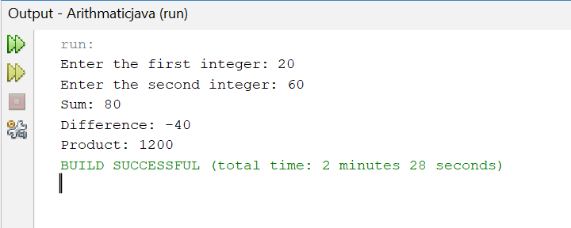

Exercise 4 (Temperature.java)

Celsius to Fahrenheit temperature: F=(C × 9/5) + 32

C = temperature in Celsius.

F = temperature in Fahrenheit

Calculate the temperature for the following degrees;

289 °C

400 °C

-36 °C

-180 °C

**Source Code:**

package first_exercise;

public class First_Exercise {

public static void main(String[] args) {

double[] celsiusTemperatures = {289, 400, -36, -180};

for (double celsius : celsiusTemperatures) {

double fahrenheit = (celsius * 9 / 5) + 32;

System.out.println(celsius + " °C = " + fahrenheit + " °F");

}

}

}

**Output:**

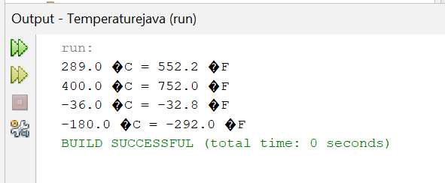

Exercise 5 (Cookies.java)

There are 12 cookies per box (sold at $1.14) and 24 boxes per carton. Left over boxes are sold for 57¢. Remaining cookies are given away free. Given the number of cookies produced, determine the number of boxes, cartons, left over boxes and the total money made.

**Source Code:**

package first_exercise;

import java.util.Scanner;

public class First_Exercise {

public static void main(String[] args) {

Scanner scanner = new Scanner(System.in);

System.out.print("Enter the total number of cookies produced: ");

int totalCookies = scanner.nextInt();

int cookiesPerBox = 12;

double pricePerBox = 1.14;

int boxesPerCarton = 24;

double priceLeftoverBox = 0.57;

int totalBoxes = totalCookies / cookiesPerBox;

int totalCartons = totalBoxes / boxesPerCarton;

int leftoverBoxes = totalBoxes % boxesPerCarton;

int remainingCookies = totalCookies % cookiesPerBox;

double moneyFromFullBoxes = (totalBoxes - leftoverBoxes) * pricePerBox;

double moneyFromLeftoverBoxes = leftoverBoxes * priceLeftoverBox;

double totalMoneyMade = moneyFromFullBoxes + moneyFromLeftoverBoxes;

System.out.println("Total number of boxes: " + totalBoxes);

System.out.println("Total number of cartons: " + totalCartons);

System.out.println("Number of leftover boxes: " + leftoverBoxes);

System.out.println("Number of remaining cookies (given away for free): " + remainingCookies);

System.out.println("Total money made: $" + String.format("%.2f", totalMoneyMade));

scanner.close();

}

}

**Output:**

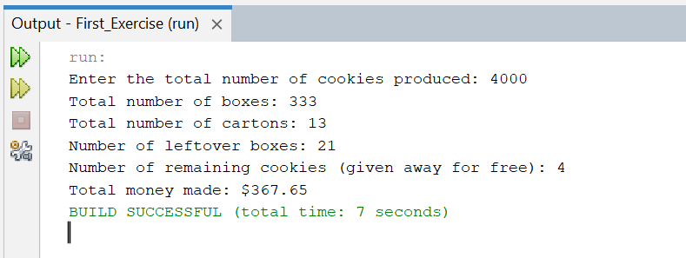

Exercise 6 (PullyFormulas.java)

Consider the following Pulley formulas:

* Calculate the speed of one pulley if there are 2 pulleys connected with a belt:

RPM2 = diameter1/diameter2 * RPM1

* Calculate the amount of weight that can be lifted with a multiple pulley system:

Weight lifted = force exerted * number of up ropes

**Source Code:**

package first_exercise;

import java.util.Scanner;

public class First_Exercise {

public static double calculatePulleyRPM(double diameter1, double diameter2, double rpm1) {

return (diameter1 / diameter2) * rpm1;

}

public static double calculateLiftedWeight(double force, int upRopes) {

return force * upRopes;

}

public static void main(String[] args) {

Scanner scanner = new Scanner(System.in);

// Input for pulley speed calculation

System.out.print("Enter the diameter of the first pulley: ");

double diameter1 = scanner.nextDouble();

System.out.print("Enter the diameter of the second pulley: ");

double diameter2 = scanner.nextDouble();

System.out.print("Enter the RPM of the first pulley: ");

double rpm1 = scanner.nextDouble();

// Calculate RPM of the second pulley

double rpm2 = calculatePulleyRPM(diameter1, diameter2, rpm1);

System.out.println("The RPM of the second pulley is: " + rpm2);

// Input for weight lifting calculation

System.out.print("Enter the force exerted (in pounds): ");

double force = scanner.nextDouble();

System.out.print("Enter the number of up ropes: ");

int upRopes = scanner.nextInt();

// Calculate the amount of weight that can be lifted

double liftedWeight = calculateLiftedWeight(force, upRopes);

System.out.println("The weight that can be lifted is: " + liftedWeight + " pounds");

scanner.close();

}

}

**Output:**

